Dear Honorable Senator :

I am writing you today, hoping you will consider among your first actions the revision to the US Corporation Income Tax Code. In particular, this program lowers the overall tax rates (which really are fictional anyway), includes a potential automatic lowering of the rates as collections increase, and will afford the US Treasury the means to lower the personal tax rates as many of you have been proposing, still leaving the tax collections sufficient to fund our needs.
The New York Times recently listed the total taxes paid by the top 50 US corporations (of the S&P 500)- and as you can see, most of these entities pay little taxes. Moreover, this list included not only the Federal taxes, but state, local, and foreign collections.
This program also removes the incentives to consider tax inversion for any corporation. It also matches the concept that the OECD (the Organization for Economic Cooperation and Development) is working to adopt. Their program is called BEPS (Base Erosion and Profit Shifting).
This program is based upon the Multistate Tax Compact that exists in the US- which ensures that each company pays its fair share of taxes to the various states where they have operations, sales, and assets. This has been the practice for multi-state businesses for decades.
Basically, this tax program means the company computes the percentage of payroll (compared to all states), percentage of revenue (compared to all states), and percentage of real estate and other corporate assets rented or owned (compared to all states). This is then averaged to determine what percentage of the state tax rate is due. (If one operates in only one state, then it's 100% for each of the three- or 100% of the state rate.)
Under this program, worldwide entities would now average the results for each country where they have sales, employees, assets, and/or operations. And, the percentage of these preferences that obtain in the US as compared to the worldwide totals is then applied to the US national tax rate. (Any US corporation that only operates domestically has no need to compute the schedule, since it would simply pay 100% of the appropriate national tax rate.)
Here is the list of proposed rates for US Corporations.
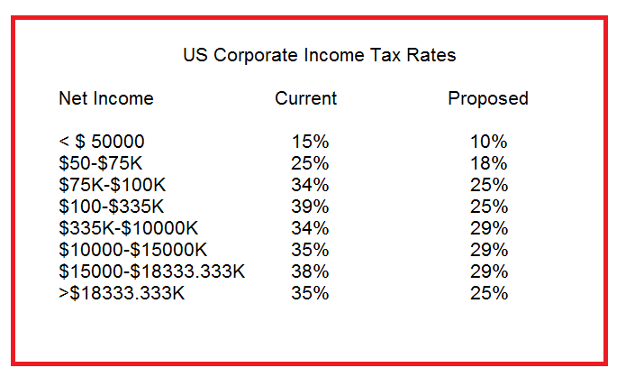

It is fairly evident that this tax system is going to raise a lot of revenue for the US Treasury Money that has been too long sheltered from the proper tax collections. As such, the program enactment should stipulate that as corporate collections of taxes increase by more than 100% over the first two years, the tax rates be automatically reduced permanently by 1% across the board. If the trend continues and the collections are still more than 75% higher over the first three years (after this reduction in rates), then the tax rates should be automatically reduced by an additional 1% (thus making the rates range from 8 to 23%).
You notice that this drop does not require another act of Congress. It will be automatic. It will keep the tax rates equitable and not excessive. The plan will ensure that a fair tax will be collected from multi-national firms, and these new corporate tax collections will adjust the ratio of funds contributed from 10, 45, 45 (business, poorer, top earners) to 25, 35, and 35- with a bigger pie (tax collections) overall.
Thank you for your consideration.
Sincerely,

